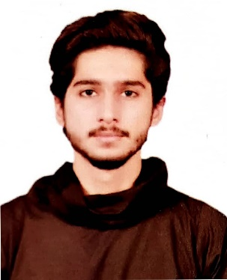**MUNEEB AHMAD**

**PERSONAL PROFILE:**

Contact : 0326 9487179

CNIC No. : 35301-4489515-5  
E-mail : Muneebahmad0317@gmail.com

**PERSONAL STATEMENT:**

Looking for a challenging role in a reputable organization to utilize my technical, database, and management skills for the growth of the organization as well as to enhance my knowledge about new and emerging trends in the IT sector and a team player.

**LANGUAGES PROFICIENCY:**

English | Urdu

**COMPUTER PROFICIENCY:**

Proficient in the day-to-day applications of the following packages:

* Microsoft Office Word
* Microsoft Office PowerPoint
* Internet Search Engine
* Microsoft Outlook
* Browsing & Net Surfing
* Computer Coding in C++
* HTML, CSS, java script & PHP
* Requirement analyst
* Software documentation
* Brainstorming

**EDUCATIONAL RECORD:**

|  |  |  |
| --- | --- | --- |
| **Year** | **Education** | **University/Institute** |
| 2020-2024 | Bachelor of Software Engineering | University of Central Punjab, Lahore (Continue) |
| 2020 | I.C.S. Intermediate in Computer Science | Punjab College of Information Technology, Muslim Town, Lahore |
| 2018 | Metric (SSC) | Govt. High School, Sector D-1, Township, Lahore |

**PERSONAL INTERESTS:**

Interests include educational seminar, playing cricket (Played by District Level), Reading informative books, Music, and movies, Walking and jogging.

**REFERENCES:**

Will be furnished upon request.